Two weeks at Vila Central Hospital, Vanuatu November 2023
  - Anne Pham, MD3, University of Melbourne
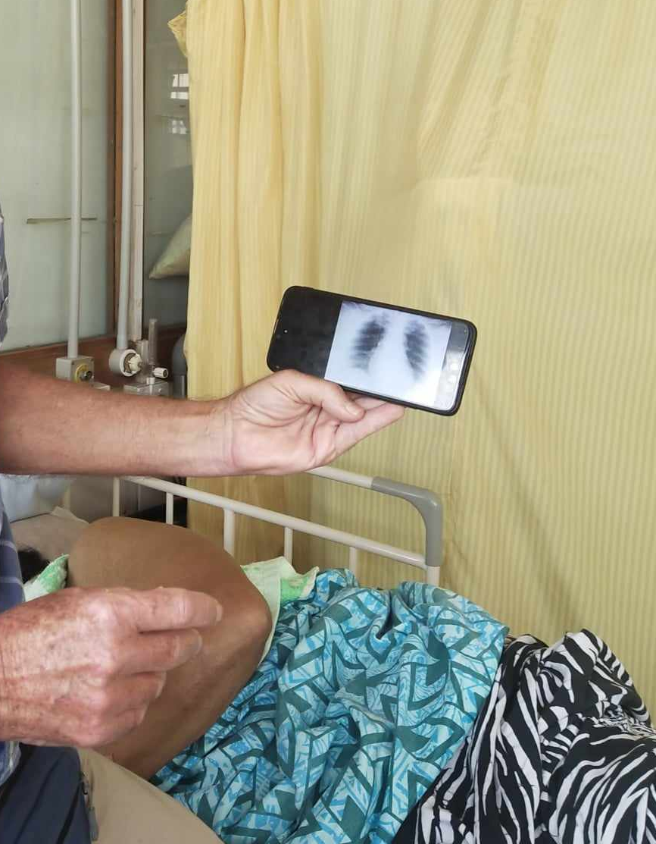
For two weeks in November 2023, I was placed with the Internal Medicine team at Vila Central Hospital, Vanuatu. This was a transformative experience, made possible through the generous support of the Andrew Dent Student Elective Scholarship. I have written this report following the conclusion of my medical elective, and it details a few of my reflections.
Resource challenges
The hospital’s limited resources were stark in comparison to hospitals within Australia. The Internal Medicine ward consisted of 36 beds in an open-dorm style, separated only by curtains. The ceiling had heavy water damage from cyclones earlier in the year. Hand sanitiser was stored in empty plastic water bottles. The patients’ bedside curtains were stained and rarely cleaned. Dr Minado was the only local consultant present during my first week, and the other consultants were overseas volunteers.
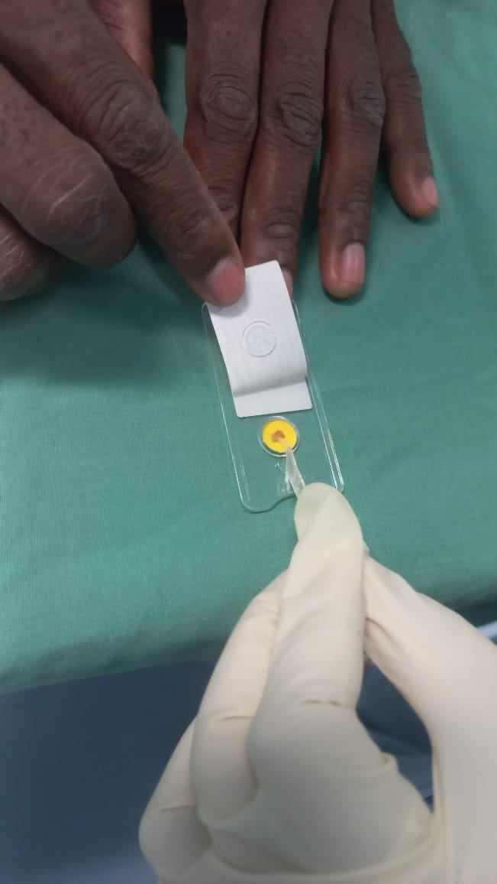
The hospital relies on overseas donations of decommissioned medical equipment, and on personal donations from volunteers. Photos of X-rays were viewed by the bedside on phones. The hospital had no CT machine or MRI machine –any urgent or necessary scans would require patients to fly to Fiji or India. There was a much greater focus on clinical reasoning and empirical treatment.
Photo 1: Patient chest X-ray being viewed on a mobile phone at the bedside
Dr Sale brought back rapid urease test kits from an overseas convention in New Zealand. I was witness to the first time H.pylori gastritis was diagnosed within Vanuatu. It put into perspective what I held for granted in the Australian healthcare system, where urease breath tests or stomach biopsy sampling are readily available.
Photo 2: First rapid urease testing performed at Vila Central Hospital
Tenacity
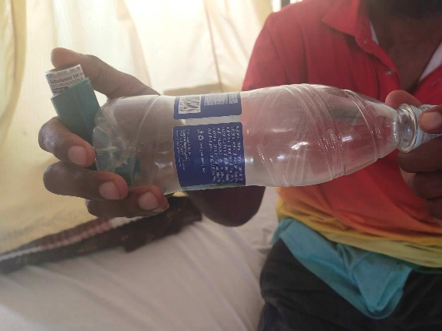
Alongside these challenges, I observed the tenacity and resourcefulness of the Ni-Vanuatu people. Asthma puffer spaces were designed from plastic water bottles. Torniquets were fashioned out of gloves. And hand sanitiser was stored in plastic water bottles. The doctors and nurses all had big hearts—an attribute which became apparent when I joined in on staff Christmas carols. The medical staff stayed behind after their work shifts to rehearse for the carols; and musical equipment and Christmas decorations were self-sourced for the hospital. It was a balmy night when we sang in the patient wards, and the gratitude from families afterwards filled me with a lasting warmth.
Photo 3: Asthma puffer spacer fashioned from a plastic water bottle
Geographical barriers and health literacy
Vanuatu consists of 83 individual islands, with around 65 being inhabited. Vila Central Hospital is the main hospital in Vanuatu, located on Efate. Patients came from all walks of life – from mountains to forests to towns. Patients on different islands would often commute by ferry to reach the hospital. Accessibility was made even more difficult by the three successive cyclones –Judy, Kevin, and Lola –that hit Vanuatu in 2023.
Furthermore, health literacy is low. For example, I met a lady in her 30s who had a mitral valve replacement years prior. Her INR levels were refractory to increasing doses of warfarin. During a moment of quiet time waiting for the doctor, she and her mother asked me to explain what INR was and why she was taking warfarin. I realised that she had difficulty understanding her heart condition and medications despite the few years she had been on warfarin.
Non-communicable disease
Low literacy rates and challenging access to health care contributes to high rates of non-communicable diseases such as obesity, Type 2 diabetes, heart failure, ischemic heart disease, dyslipidemia, and hypertension. Patients would have very late presentations of their conditions. For example, there was a man in his 50s who was admitted in critical condition to the ICU for sepsis secondary to an ascending foot infection. He had a background of chronic type 2 diabetes and foot ulcers. Patients with cancer often presented with widespread metastases. Stroke patients often had delayed transfers to hospital, and sadly, one of those patients died secondary to brain oedema and herniation.
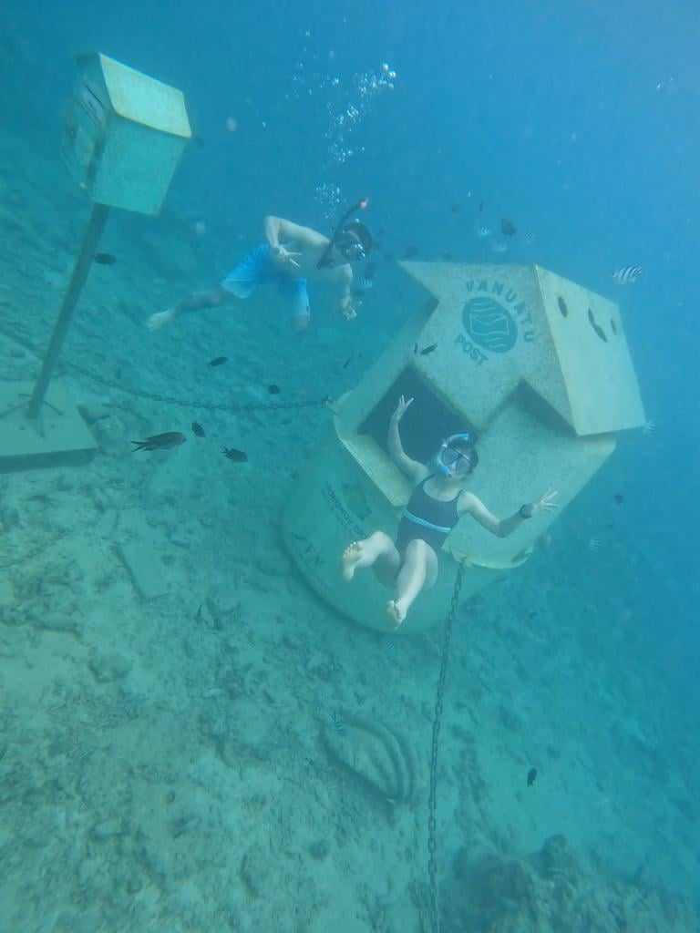
Travel
I was fortunate to undertake my placement with a close friend. We tried market foods cooked by local mums, ranging from ‘lap lap’ to ‘simboro’. These dishes were made from delicious local produce: taro, yam, cassava, coconut milk, and island cabbage to name a few. In our spare time, we explored both Efate and Santo islands. Our highlights included hiking, kayaking, and snorkelling.
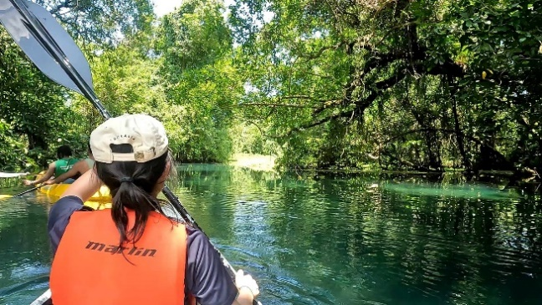

Photo 4: Underwater post office on Efate

Photo 3: Kayaking to blue holes on Santo

Final remarks
Overall, my trip to Vanuatu was incredible in terms of learning medicine, experiencing cultures, and creating memories. I am deeply grateful to the Pacific Health Fund for granting me this opportunity and hope one day to return to the Pacific.

